Manual for AlaScan 32bit, v 1.5

Manual version 11.09.2011

Dmitry Veprintsev

The AlaScan software designs mutagenesis primers for Ala/Gly scanning mutagenesis.

The mutatgenesis protocol is to PCR amplify the plasmid with two primers leaving thwe 13-15 bp overlap for the Ecoli DNA repair machinery (or ClonEASY) to circularise the plasmid again. The mutation site would be at or near the overlap.

The input of the programm is the DNA sequence of the coding region to be mutagenised flanked by approx. 50 bp of the upstream and downstream sequences (shown in UPPER case in example below).

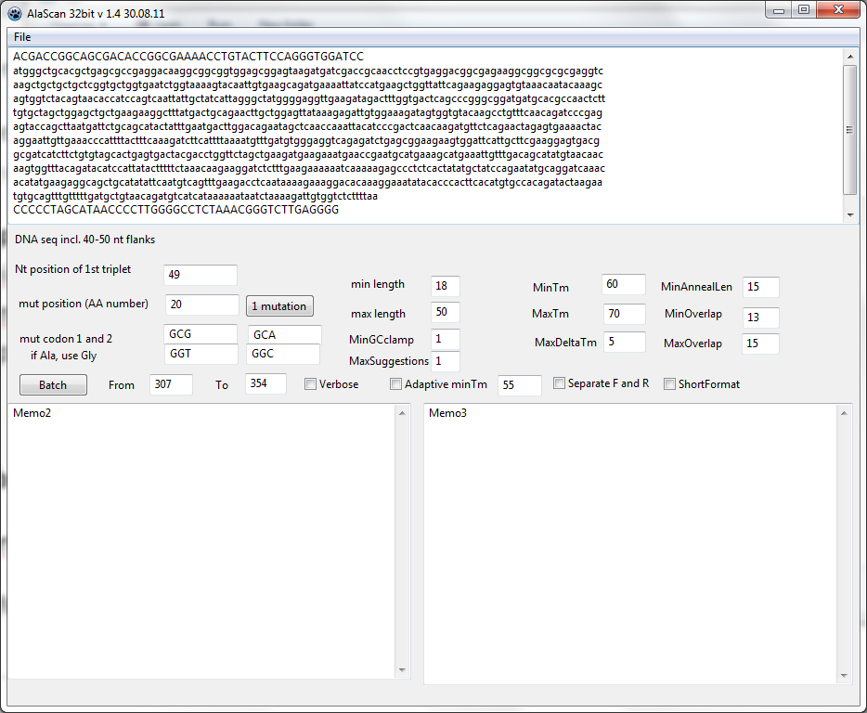

**Nt position of the first triplet** points to a first nucleotide of the coding sequence. In the example above, the flanking region in UPPER case was 48 nt long, and the position of the first codon is at 49 nt.

The program will use the **mutagenesis codon** which introduces the least number of mismatches. The defaults are the two preferred codons for **Ala** and **Gly** according to DNA2.0. If the current aminoacod is already Ala, it will be replaced by Gly.   
**NOTE:** Other desired substitutions can be used instead. Just put desired codon(s) in positions for both Ala and Gly and manually verify if you are not trying to replace the amino acid by itself.

The region to be **Batch** scanned is **From** and **To** in aminoacid position (1st aminoacid is at Nt of the first codon).

Single mutation can also be mutated using **mut position** and 1 MUTATION button

The programm will attempt to design the **shortest** primers (length between **min length** and **max length**), with the Tm as close to **minTm** as possible, not exceeding the **MaxTm**, with the maximal Tm difference between forward and reverse Tm is **MaxDeltaTm**.

Tm is calculated **excluding** mistmatches according to the formula

**Tm =  64.9°C + 41°C x (number of G’s and C’s in the primer – 16.4)/N**

See <http://www.promega.com/techserv/tools/biomath/calc11.htm>

The number of G or C at the 3’ end is **minGCclamp.** Set to **0** is it is not required**.**

**OptimisedGCclamp will calculate GC clamp score according to**

**PCR primer selection tool optimized for highthroughput proteomics and structural genomics**

**Jaume M. Canaves, Andrew Morse, and Bill West**

**University of California San Diego, La Jolla, CA, USA**

**BioTechniques 36:1040-1042 (June 2004)**

**[GC][GC][GC] = 0; [ATGC][ATGC][AT] = 1; [ATGC][AT][GC] = 2; and [AT][GC][GC] = 3,**

**with 0 corresponding to the worst GC clamp and 3 corresponding to the best, respectively.**

The program will generate **Maxsuggestion** number of possible pairs.

The overlap of the resulting PCR fragment is between **MinOverlap** and **MaxOverlap**. Default 13 to 15 bp.

The minimal distance from the mutation codon to the 3’ end of the primer is **MinAnnealLen**.

If the output is preferred to be separated for F and R oligos, than use **Separate F and R** checkbox. Convenient for generating oligo orders.

**Adaptive Tm option** can be used when for some positions in the gene no oligos can be generated withing the constrain of max length and min Tm. For these positions only, the program will decrease the minTm by 1C until it can generate a primer satisfying over constraint. Increasing MaxLength of the primer to 50 bp may be a better alternative.

**Verbose** activates additional information printout which may help to troubleshoot the program.

**ShortFormat** generates a list of only oligo name and sequence – convenient for generating orders

**File/Open** and **File/Save** allow opening and saving of the projects (sequences and options)

## Output example

307_F gtcagXXXgaagacctcaataaaagaaaggacac len=34 Tm=60.4 GCclamp=1 AnnLenF=26 gtcagGCGgaagacctcaataaaagaaaggacac

307_R ggcagctgcatatattcaatgtcagXXXgaaga len=33 Tm=60.3 GCclamp=3 AnnLenR=25 tcttcCGCctgacattgaatatatgcagctgcc

total length of designed oligos xxxx nt

307_F and 307_R are aminoacid position and primer direction

The first sequence with the mutagenesis codon capitalised and XX for mismatches in on the coding strand for both F and R primers.

**Len** is the length of primer.

**Tm** is predicted Tm **excluding** mismatches.

**GCclamp** is the number of G or C nucleotides at 3’ end of the primer.

**AnnLen** is ht elength from the mutation codon to the 3’ end of the primer.

The final primer sequence is the one to order , from 5’ to 3’. It is already ReverseComplemented for the Reverse primer.

The mutation codon is capitalised.

Individual values are seprated by a **SPACE**.

total length of designed oligos is the exacly that - used to calculate the price of the order.